Dr. Cheryl L Brown, Director  Jacksonville City Council  904.630.1452  CLBrown@coj.net | 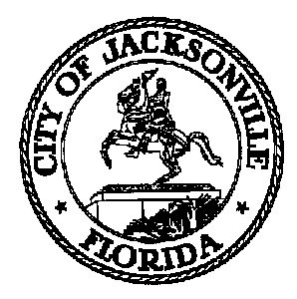 | 117 West Duval Street, Suite 425  Jacksonville, Florida 32202
TASK FORCE ON SAFETY AND CRIME REDUCTION

Meeting Notice

January 18, 2019
5:00 p.m.

TO: Consolidated Government Task Force Members

Sam Newby, Vice Chair | E. Joyce Bolden | Tom Geismar | Linda Joseph
Lori Boyer | Francois Brown | William (W.C.) Gentry | Ronnie King
Charles Moreland | Ricky Brown | Ellen Glasser | Sean Mulholland
Lakesha Burton | Camille Burban | Jeff Golden | Michael Munz
Stephen Siegel | Betty Burney | Shelley Grant | Ceil Pillsbury-Schellenberg
Rob Mason | Josh Cockrell | Constance Hall | Alicia Sitren
Joe Peppers | Larry Cook | Phyllis Hall | Timothy Sloan
Jennifer Blalock | Richard Danford | Marian Hannah | Vicki Waytowich
Warren Jones | Frank Denton | Darcel Harris | Donna Webb
Mia Allen | Amy Donofrio | Preston Harris | Shamika Baker Wright
Brandon Griggs | Sabrina Edwards | Sam Harrison
Clifton Anderson | Ben Frazier | Carolyn Herman

FROM: Mark Griffin, Chair

SUBJECT: Task Force on Safety and Crime Reduction Meeting Notice 1.25.19

Notice is hereby given that the Task Force on Safety and Crime Reduction will meet Friday, January 25, 2019 at 9:00 A.M.. The meeting will held in the Council Chambers located at 117 W. Duval St., 1st Floor, City Hall - St. James Building.

When attending Task Force meetings, members are to park in the parking garage located on the corner of Main and Duval Street (Library Garage) to receive free parking. Please see at each meeting for parking validation.

cc: Cheryl Brown, Council Director
Carol Owens, Chief of Legislative Services
Jeff Clements, Chief of Research
File
cityc@coj.net

